1. 
2. Topic is where Kafka stores messages.
3. 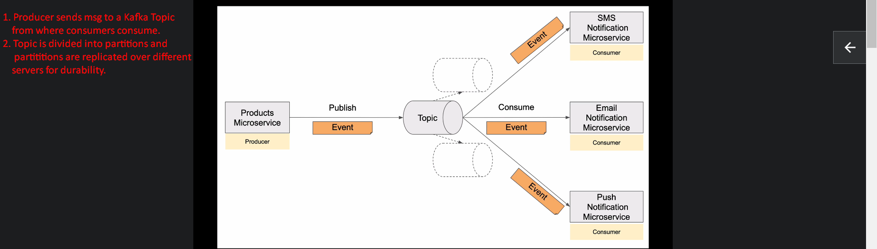
4. Let’s look at the Kafka Topic in more Detail.
5. Each topic has a unique name as you can see “product-created-event-topic”.
6. A topic can be split into partitions as on my screen they are 3.   
   It is helpful as multiple consumers can read from these partitions in parallel.  
   This could help in
   1. Scaling our system.
   2. Making our system faster.
   3. More throughput.
7. # of partitions is decided at the time of topic creation. Later on we can increase the size but can’t decrease the size.  
   